A Mini Project Report
on
Company Profile Website
by

roshan kajulkar (TI019)
kamal kant (TI020)
harshal pathak (TI054)
yogesh patil (TI027)

Under the guidance of
Prof. Vishal Choudhary
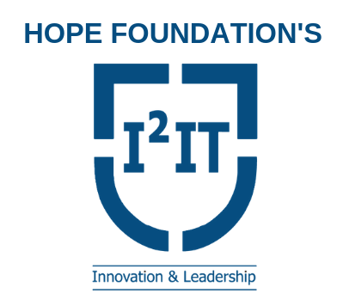

Department of Information Technology
International Institute of Information Technology.
SAVITRIBAI PHULE PUNE UNIVERSITY
2019-2020
Department of Information Technology
International Institute of Information Technology

Date:
CERTIFICATE

This is to certify that,

roshan kajulkar (TI019)
kamal kant (TI020)
harshal pathak (TI054)
yogesh patil (TI027)

of class T.E IT; have successfully completed their mini project work on “Company Profile Website’’ at International Institute of Information Technology in the partial fulfillment of the Graduate Degree course in T.E at the department of Information Technology, in the academic Year 2019-2020 Semester – 5 as prescribed by the Savitribai Phule Pune University.

Prof. Vishal Choudhary Prof. Sarang Saoji
Guide Head of the Department
(Department of Information Technology)

Acknowledgements
We would like to express our most sincere thanks to the following:
First and the foremost, to our guide and mentor throughout the semester, for the subject, Software Laboratory-3 – Prof. Vishal Choudhary, for motivating us and counseling us through the highs and lows of this project.
To the Principal – Dr. Vaishali Patil, and to our Head of Department – Prof. Sarang Saoji; for providing us the opportunity to execute our ideas and exhibit them in an impeccable manner.
To our management and lab attendants, for providing us the access to the resources and for the chance of widening our ground of experience.
A generous thanks to our friends, for being there, to always help out in times of hardship and adversities.
And finally, a debt of gratitude, love, and respect towards our families; for teaching us always to be curious and to ask difficult questions.

Roshan kajulkar
kamal kant
harshal pathak
yogesh patil

Abstract

HRK TECHNICAL is a website, which is company profile website.It is a web development company which is known for building websites.The website consist of company details ,there past projects and contact information.It also consist of their expertize domains.

Introduction

Problem Statement
Build a website using html css and javascript.

Literature
Advantages and Benefits of Company profile website
WHO BENEFITS FROM A Company profile websiteAND HOW?
Having a company profile website is beneficial for both the company owners as well as their clients.The company is able to demonstrate their past projects as well as they are able to make all this information available globally online.
The clients also are benefited as they are able to know companies information and their past project before hand online.

Software Requirement Specification
1 Hardware Requirements
- Processor : Any Processor above 500 MH
- RAM : 128MB
- Hard Disk : 10GB
- Compact Disk : 650MB
- Input Device : Standard Keyboard and Mouse
- Output Device : High Resolution Monitor

2 Software Requirements
- VSCODE Editor
- Chrome

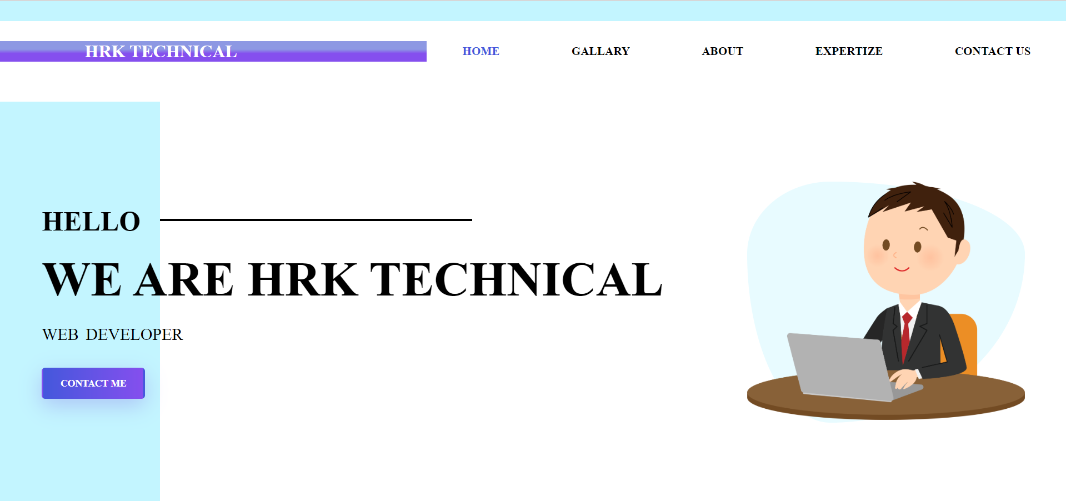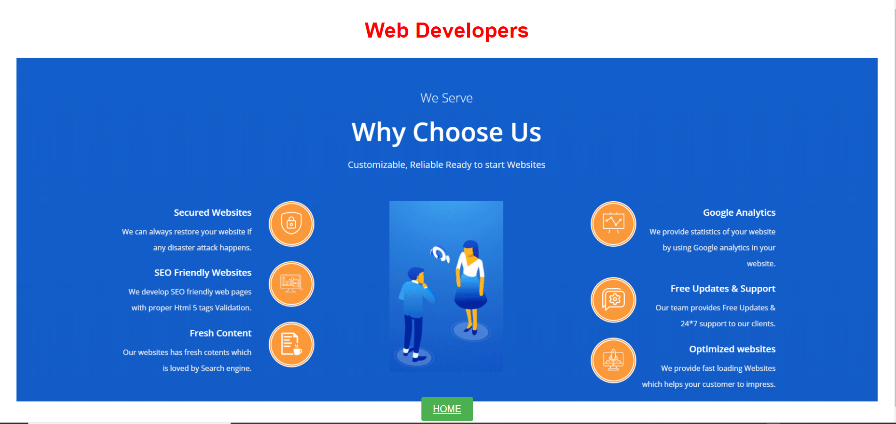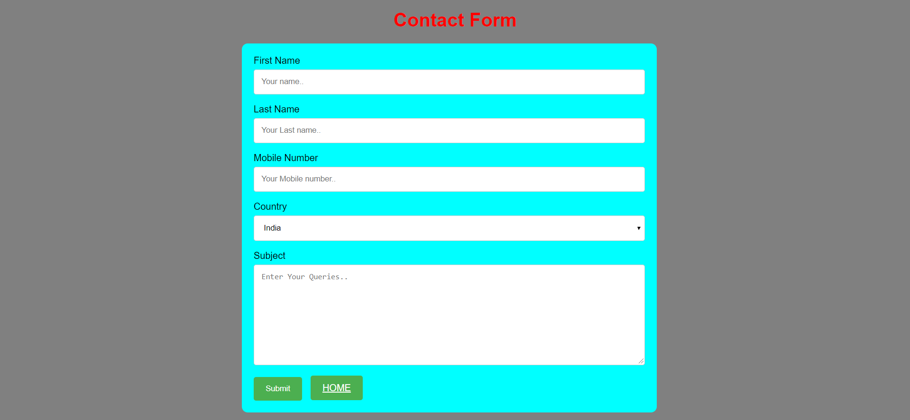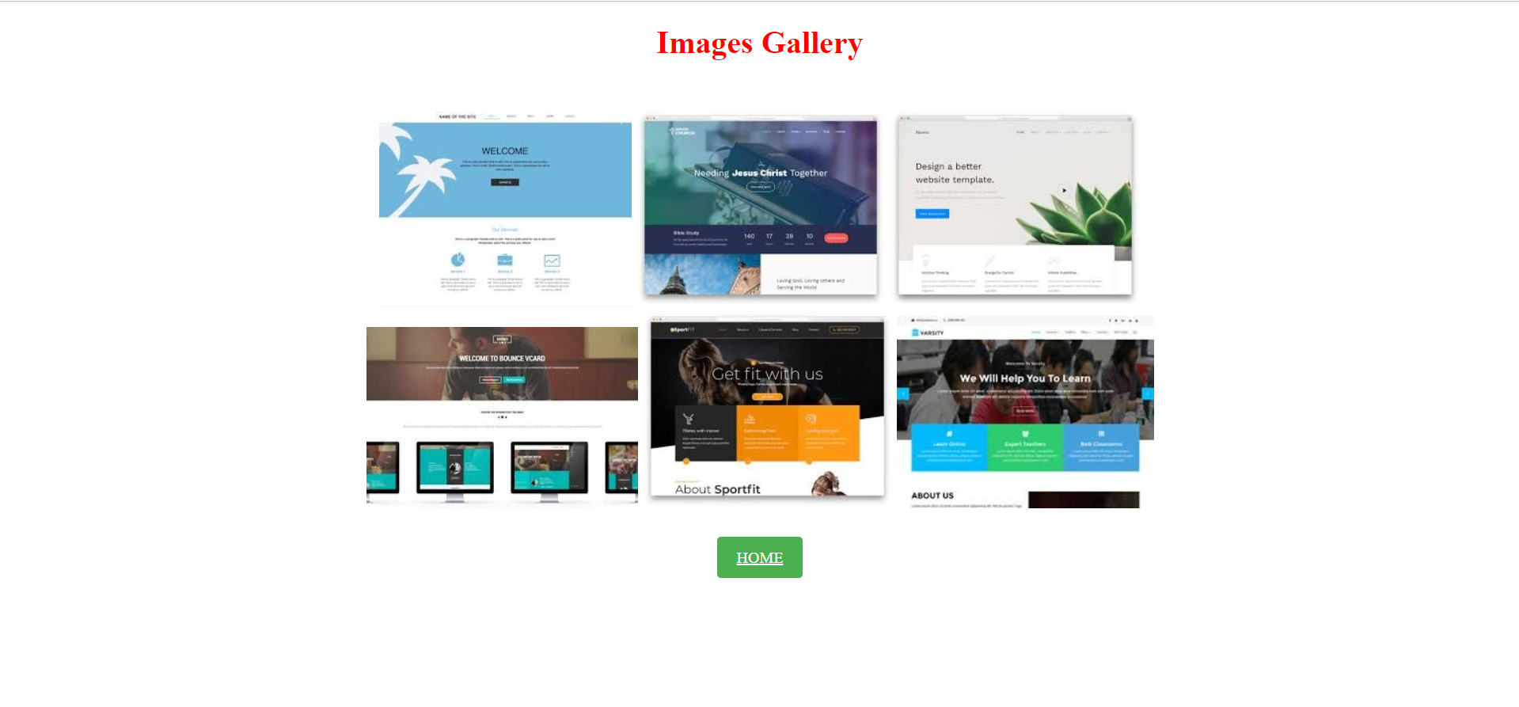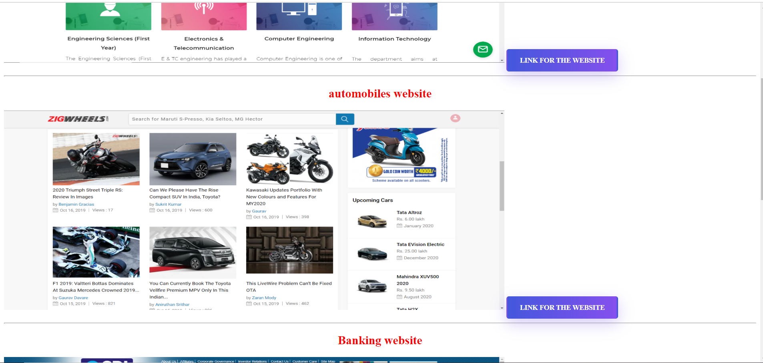

Conclusion
To conclude, a company profile website can be used to spread popularity of the company and it could also help potential client to search for the company .We have made efficient use of web development tools, and an attractive GUI is created .
References

“CodePen.” Wikipedia, Wikimedia Foundation, 16 Aug. 2018, en.wikipedia.org/wiki/CodePen.

Peterstuartmill. Digital image. Pixabay. N.p., July 2014. Web. 31 July 2015.

Youtube (2019). HTML AND CSS Introduction

